1/1/2025

**ENERGO**

**Communcation & Electronics Engineering**



***Abstract***

In light of the ongoing climate and weather problems in the world and their direct impact on humans and the environment around them, we, the EnerGO team from the Nile Higher Institute of Engineering and Technology, have tried to find a solution that will help us, our people, and our environment. We look forward to expanding to the entire Middle East by creating a car that runs on solar energy and a dynamo, making it a good and competitive alternative to existing cars in the market in terms of price, efficiency, and periodic maintenance. Below, we will review the most important components of the car and some of the features of its competitors through:

**[A] Electric Car**

**[B] Green Cars**

**[C] Solar Panels**

**[D] Batteries**

**[E] Dynamo**

**[F] EnerGO**

***Abstract* 1**

I

**In recent years, the world has been suffering greatly from global warming and air pollution, which are primarily linked to internal combustion engine vehicles. Therefore, our goal in this project is to solve this problem. We, the EnerGo team, are creating a car that is beneficial to the environment and to the human factor, both in terms of costs. We have created a car that relies primarily on solar cells and self-charging methods based on a dynamo. Through these methods, we have saved the environment from radiation pollution resulting from fuel, and the human factor from the cost of electric charging stations available for electric cars. Here, we have provided a comprehensive and integrated overview of scientific research related to electric vehicles, their environmental impact, and the impact of EnerGo, in addition to its most important distinctive components. [A] Electric Car [B] Green Cars [C] Solar Panels [D] Batteries [E] Dynamo [E] EnerGo**

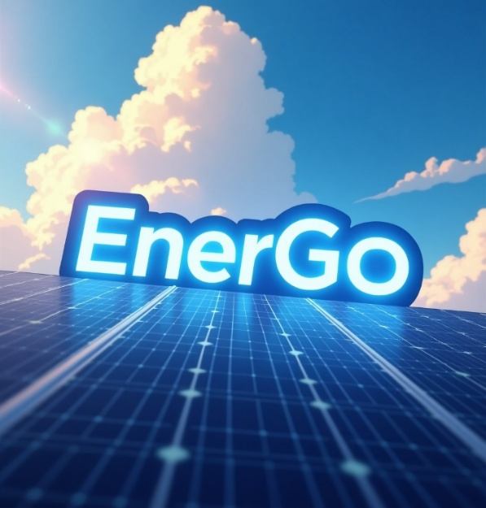

**INTRODUCTION**

Fearsthat electric cars could actually increase carbon emissions are unfounded in almost all parts of the world, new research shows Reports have questioned whether electric cars really are greener’ once emissions from production and generating their electricity are taken into account. But a new study by the universities of Exeter, Nijmegen and

Cambridge has concluded that electric cars lead to lower carbon emissions overall, even if electricity generation still relies on fossil fuels[1]. The results[2] are reported in the journal Nature Sustainability.Under current conditions, driving an electric car is better for the climate than conventional petrol cars in 95% of the world.Average lifetime emissions from electric cars are up to 70% lower than petrol cars in countries like Sweden and France (which get most of their electricity from renewables and nuclear), and around 30% lower in the UK.The study projects that by 2050, every other car on the streets could be electric[1]. This would reduce global CO2 emissions by up to 1.5 gigatons per year, which is equivalent to the total current CO2 emissions of Russia."Even in our worst-case scenario, there would be a reduction in emissions in almost all cases. This insight should be very useful for policy-makers.""Taking into account emissions from manufacturing and ongoing energy use, it’s clear that we should encourage the switch to electric cars and household heat pumps without any regrets," Knobloch said[2].

**INTRODUCTION 1**

How we at Energo

We worked on the problems of electric cars and solved the largest number of them at Energo

**"Reliance on Gasoline to Generate Electricity for Charging Stations"**

In most countries, charging stations rely on a large chunk of the greenhouse gases that blanket the Earth and trap the sun's heat. These gases are generated through energy production, by burning fossil fuels to generate electricity and heat.

Fossil fuels, such as coal, oil, and gas, are by far the largest contributor to global climate change, accounting for over 75 percent of global greenhouse gas emissions and nearly 90 percent of all carbon dioxide emissions.

The science is clear: to avoid the worst impacts of climate change, emissions need to be reduced by almost half by 2030 and reach net-zero by 2050.

To achieve this, we need to end our reliance on fossil fuels and invest in alternative sources of energy that are clean[50]

In energo

Basically, we do not need stations to charge the car

**"Long charging time"**

The time it takes to charge an electric car can be as little as 30 minutes or more than 12 hours. This depends on the size of the battery and the speed of the charging point.

A typical electric car (60kWh battery) takes just under 8 hours to charge from empty-to-full with a 7kW charging point.[51]

But at Energo, we rely on self-charging via solar cells.

**"Charging station infrastructure"**

Across Egypt, there are only 200 charging points. This is a difficult number considering the geographical distribution of a large country like Egypt, which has 700 charging points [52].

This prompted us to try to create a car that doesn't need charging stations in most cases.

**"Lithium battery in electric car"**

In the first version of Energo, we relied on acid batteries due to the problems with lithium batteries.

The manufacture of lithium-ion batteries consumes natural resources such as lithium and cobalt, leading to environmental pollution and unsustainable mining.

**"The high price of electric cars"**

Despite the decline in prices over time, electric cars are still more expensive than conventional cars, making them unaffordable for everyone.

At Energo, we tried to keep the price as affordable as possible for the user while using environmentally friendly components.

**[A] Electric Car**

**How Do All-Electric Cars Work?**

All-electric vehicles, also referred to as battery electric vehicles (BEVs), have an electric motor instead of an internal combustion engine. The vehicle uses a large traction battery pack to power the electric motor and must be plugged in to a wall outlet or charging equipment[4], also called electric vehicle supply equipment (EVSE). Because it runs on electricity, the vehicle emits no exhaust from a tailpipe and does not contain the typical liquid fuel components, such as a fuel pump, fuel line, or fuel tank.[3]

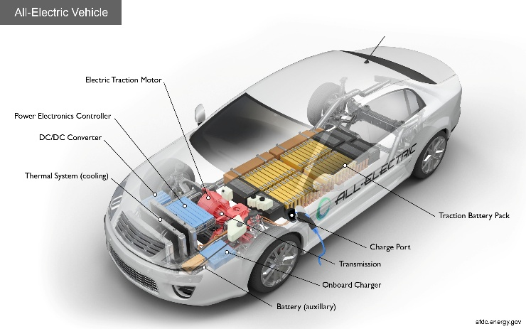

**Key Components of an All-Electric Car :-**

**Battery (all-electric auxiliary):** In an electric drive vehicle, the auxiliary battery provides electricity to power vehicle accessories.

**Charge port:** The charge port allows the vehicle to connect to an external power supply in order to charge the traction battery pack.

**DC/DC converter:** This device converts higher-voltage DC power from the traction battery pack to the lower-voltage DC power needed to run vehicle accessories and recharge the auxiliary battery.Electric

**traction motor:** Using power from the traction battery pack, this motor drives the vehicle's wheels. Some vehicles use motor generators that perform both the drive and regeneration functions.

**Onboard charger:** Takes the incoming AC electricity supplied via the charge port and converts it to DC power for charging the traction battery. It also communicates with the charging equipment and monitors battery characteristics such as voltage, current, temperature, and state of charge while charging the pack.

**Power electronics controller:** This unit manages the flow of electrical energy delivered by the traction battery, controlling the speed of the electric traction motor and the torque it produces.Thermal

**system (cooling):** This system maintains a proper operating temperature range of the engine, electric motor, power electronics, and other components.Traction battery pack: Stores electricity for use by the electric traction motor.

**Transmission (electric):** The transmission transfers mechanical power from the electric traction motor to drive the wheels.[3]

**How Do Plug-In Hybrid Electric Cars Work?**

Plug-in hybrid electric vehicles (PHEVs) use batteries to power an electric motor and another fuel, such as gasoline, to power an internal combustion engine (ICE). PHEV batteries can be charged using a wall outlet or charging equipment, by the ICE, or through regenerative braking. The vehicle typically runs on electric power until the battery is nearly depleted, and then the car automatically switches over to use the ICE.[6]

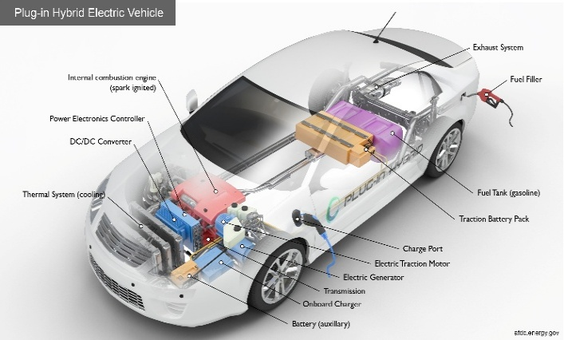

**Key Components of a Plug-In Hybrid Electric Car:-**

**Battery (auxiliary):** In an electric drive vehicle, the low-voltage auxiliary battery provides electricity to start the car before the traction battery is engaged; it also powers vehicle accessories.

**Charge port:** The charge port allows the vehicle to connect to an external power supply in order to charge the traction battery pack.

**DC/DC converter:** This device converts higher-voltage DC power from the traction battery pack to the lower-voltage DC power needed to run vehicle accessories and recharge the auxiliary battery.

**Electric generator:** Generates electricity from the rotating wheels while braking, transferring that energy back to the traction battery pack. Some vehicles use motor generators that perform both the drive and regeneration functions.

**Electric traction motor:** Using power from the traction battery pack, this motor drives the vehicle's wheels. Some vehicles use motor generators that perform both the drive and regeneration functions.

**Exhaust system:** The exhaust system channels the exhaust gases from the engine out through the tailpipe. A three-way catalyst is designed to reduce engine-out emissions within the exhaust system.

**Fuel filler:** A nozzle from a fuel dispenser attaches to the receptacle on the vehicle to fill the tank.

**Fuel tank (gasoline):** This tank stores gasoline on board the vehicle until it's needed by the engine.

**Internal combustion engine (spark-ignited):** In this configuration, fuel is injected into either the intake manifold or the combustion chamber, where it is combined with air, and the air/fuel mixture is ignited by the spark from a spark plug.

**Onboard charger**: Takes the incoming AC electricity supplied via the charge port and converts it to DC power for charging the traction battery. It also communicates with the charging equipment and monitors battery characteristics such as voltage, current, temperature, and state of charge while charging the pack.

Power electronics controller: This unit manages the flow of electrical energy delivered by the traction battery, controlling the speed of the electric traction motor and the torque it produces.

**Thermal system (cooling):** This system maintains a proper operating temperature range of the engine, electric motor, power electronics, and other components.

**Traction battery pack**: Stores electricity for use by the electric traction motor.

**Transmission:** The transmission transfers mechanical power from the engine and/or electric traction motor to drive the wheels.[5]

**[B] Green Cars**



**Are Electric Cars Better for the Environment?**

The transportation sector continues to a significant source of pollution and greenhouse gas emissions – and electric cars can help tackle the climate change problem, and contribute to better air quality.

Simulations have shown that widespread EV adoption would aid in limiting global warming by at least two degrees Celsius, which would help meet one target of the 2016 Paris Agreement. Nine countries, including the U.S., have announced their intent to restrict or ban the use of all internal combustion engines and reduce national tailpipe emissions to zeroat some time in the future.[8]

Zero emissions – no stinky fumes – makes going electric feel good. But we also need to look at well-to-wheel emissions – all of the emissions related to the production, processing, distribution and use of electricity. Most electric power plants produce emissions, and there are additional emissions associated with every step of the energy production cycle. On this basis, electric cars emit an average of 4,100 lbs. of carbon dioxide (CO2) equivalent each year – while traditional gasoline vehicles emit an average of 11,435 lbs. of CO2 equivalent each year. So, well-to-wheel, electric cars produce less than half the emissions of gasoline vehicles.

The best way to maximize the environmental benefits of an electric car and minimize its associated emissions is by sourcing your electricity from renewable energy. If you are planning to purchase an electric car and want to lower your total emissions, consider asking your local power utility or community choice aggregation (CCA) about special programs or offers. You could also consider installing solar panels.[8]

**Are Electric Cars Cheaper Than Gas Cars?**

Depending on how much you drive, electric cars could potentially help you save hundreds of dollars a month just in fuel costs. If you are able to charge your EV at home[10], for every given mile of driving, the cost to recharge with electricity will be a fraction of what the same mile would cost in gasoline. The costs to charge an EV at a public charger will vary based on charging speed, location, and other variables.

Depending on how much you drive, the accumulated savings in fuel costs could have a significant impact on your household budget. If, like most EV owners, you will charge at home most of the time, many utility providers even offer EV drivers lower rates during off-peak hours.[8]

Lower maintenance costs are another attraction. Thanks to the simplicity of their drivetrains, electric cars have fewer moving parts than gasoline vehicles – there are no oil changes, no transmission rebuilds, and regenerative braking means that wear and tear on the braking system is reduced as well.

While the technology in EVs comes at a price – they generally have higher suggested retail prices than most gasoline vehicles .

most electric cars are eligible for financial incentives[11] from federal, regional, and even local governments that can lower their total cost of ownership. The biggest is the federal incentive, which offers up to $7,500 off the MSRP of eligible vehicles, and which can now be claimed by your dealer at the time of purchase. Some utility companies and other agencies also offer incentives to EV buyers.[8]

**The EV Driving Experience**

You won’t sacrifice performance by going electric – quite the opposite, in fact. EVs are smoother and quieter than gasoline vehicles, and offer impressive acceleration and speed. Unlike gasoline engines, electric motors deliver peak torque instantaneously – there’s no waiting for revs to build or for the transmission to shift.

Indeed, J.D. Power recently conducted its second-annual consumer satisfaction survey focused on electric vehicles. Its 2022 Electric Vehicle Experience (EVX) Ownership Study surveyed over 8,000 owners [12]of electric vehicles. Overall, it found that making the electric car “leap of faith” proved highly satisfactory for the majority of electric vehicle owners, and that drivers would not go back to gasoline.[11]

**Long Term Savings With an EV**

Electric vehicles might have a higher upfront price tag (tax credits and incentives may offset this), but the savings come in over the longer term with lowered maintenance and zero gasoline costs. You might spend a bit more upfront, or on monthly lease payments, but if you drive enough, the savings will come back to you over time.

Indeed, according to energy.gov, on average it costs about half as much to drive an electric vehicle when just taking into consideration energy costs (gas vs. electricity). When you factor in reduced maintenance costs as well, the savings could potentially be even greater.And you get all of these benefits while experiencing an amazing driving experience – and producing no tailpipe emissions.[9]

**[C] Solar Panels**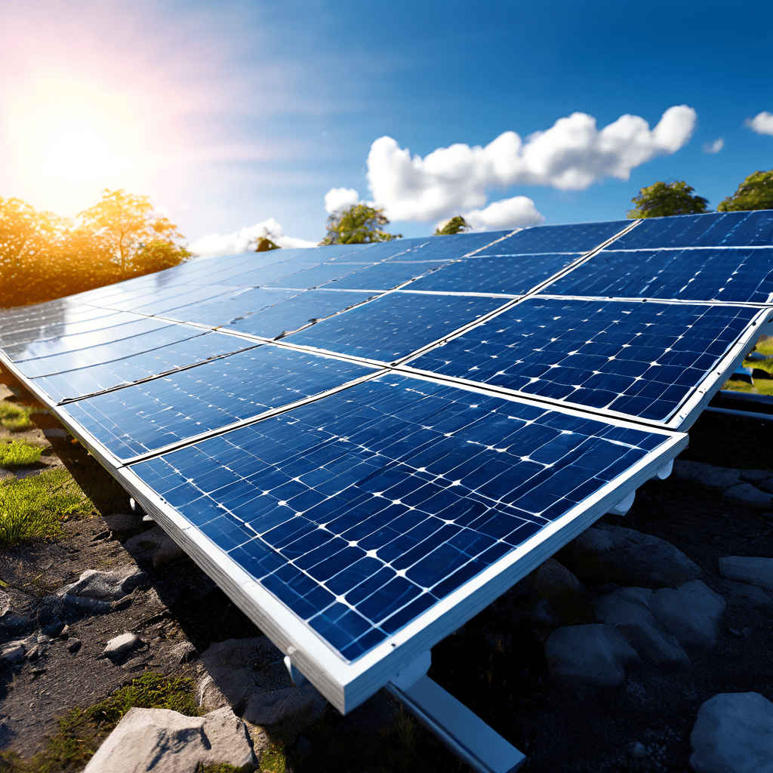

**What is solar energy?**

Today, we use solar energy in two ways: in the form of rooftop solar panels that can produce heat and district heating, and solar cells that can produce electricity.[13]

**Why is solar energy important?**

The sun is our largest source of energy, and if we knew how to make optimal use of it, we would easily be able to supply the whole world with energy. Today, only a few per cent of the world’s energy supply comes from solar energy. That number must be increased to achieve the climate goals.[24]

**Types of Solar Panels**[14]

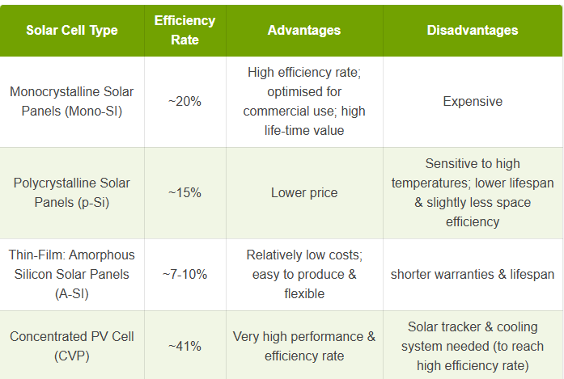

**The best type of solar panel**

**Monocrystalline solar panels are the best type of solar panel in terms of efficiency**. Their ability to capture sunlight is higher than both polycrystalline panels and thin-film solar panels. This is also why they are more expensive than cheap solar panels[15], which are almost always made from polycrystalline.

All black solar panels [16] and most integrated solar panels [17] are monocrystalline in nature. Compared to the process for polycrystalline panels, the structure of the silicon is aligned better in mono panels. As a result, they have higher sunlight absorption rates.

Monocrystalline panels are made from pure refined silicon in a pulling process. They can also be produced as “passivated emitter and rear contact” (PERC) panels which gives them the ability to reflect back unabsorbed sunlight through a back cell. This gives them a higher efficiency rate than traditional monocrystalline cells. The most efficient type of

monocrystalline solar panels you can install are bifacial solar panels. Check out our dedicated guide: "What are bifacial solar panels?"[18].

However, just because they are better in terms of efficiency doesn’t mean they are right for your setup. The other types have their own advantages and uses.[14]

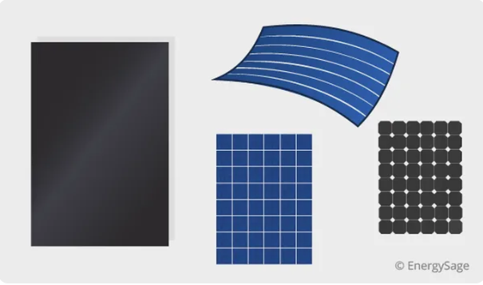

**How expensive are different types of solar panels?**

Each type of panel comes with a different price tag, primarily due to differences in the manufacturing processes.

**Monocrystalline solar panels:** The most expensive

Monocrystalline panels are usually the most expensive solar panel type. Manufacturers must absorb the costs of making solar cells from a single crystal. This process, known as the Czochralski process, is energy-intensive and results in wasted silicon. But don't worry–this silicon can later be used to manufacture polycrystalline solar cells.[15]

**Polycrystalline solar panels:** Less expensive

Polycrystalline solar panels are typically cheaper than monocrystalline panels. The cells come from silicon fragments rather than a single, pure silicon crystal. This allows for a much simpler cell manufacturing process, costing less for manufacturers and homeowners who install the panels.[15]

**Thin-film solar panels:** It depends!

What you pay for thin-film solar cells largely depends on the type of thin-film panel. CdTe is generally the cheapest type of solar panel to manufacture. CIGS solar panels are much more expensive to produce than CdTe or amorphous silicon.[15]

The overall cost of a thin-film solar panel installation is usually lower than a monocrystalline or polycrystalline solar installation. Thin-film solar panel installations are less labor-intensive because the panels are lighter and more maneuverable. It's easier for installers to carry them onto rooftops and secure them. Installers generally charge less for labor with thin-film panels, making the installation less expensive overall.[15]

**solar cells in Car**

**1- Solar cells (viSono)**

The roof, bonnet and large parts of the outer shell of the body are equipped with highly efficient monocrystalline silicon cells (especially efficient in diffuse light, aiming to load 100% of their potential capacity at angles of incidence down to 70°) which are protected by a layer of polycarbonate. The startup uses the product name viSono. The total area of the 330 photovoltaic modules is 7.5 square metres (81 sq ft) with an announced efficiency of 21%. The maximum total power output is 1208 Wp, which means that the daily range gained in Central Europe is at a maximum of 34 kilometres (21 mi) a day under favorable conditions (sunshine) and on average over a whole year about 10 kilometres (6 mi) a day.[19]

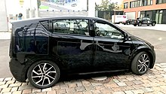

**2-Aptera**

**Solar That Fits Any Shape [21]**

* Energy production up to 0.23 kW/m²
* Capable of high compound curvature
* Designed to last 15+ years in accordance with IEC and UL standards
* 58% thinner and lighter than competing automotive solar panels
* Impact resistant to both automotive and solar standards
* Automotive-grade vibration resistance

**Bleeding-Edge Solar Charge Controller [20]**

* Charge conversion efficiency up to 94%
* Dual conversion stages boosting up to 400V
* Custom maximum power point tracking algorithm
* Fully CAN integrated
* Up to 10 solar inputs
* Automotive grade engineering

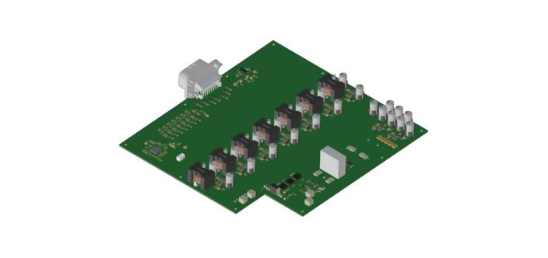

**3-Sion solar cars**

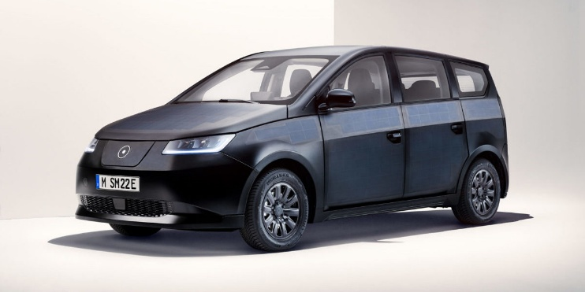

Sion’s outer shell featured 456 monocrystalline solar half cells to extend the time between charges and enable self-sufficiency on short journeys. Its 54 kWh lithium-iron phosphate (LFP) battery would allow for a maximum charging capacity of up to 75 kW (DC) and 11 kW (AC). The vehicle also had an 11 kW, on-board bidirectional charger.[22]

**[D] Batteries &Charge**

**Electric vehicles charging locations**

It may sound obvious, but with a gas vehicle, you can pretty much only fill up your tank at a gas station. With an EV, however, you can charge your car pretty much everywhere[26]: at home, at the office, at a restaurant, whilst doing your shopping, whilst parked on the street, or you can top-up your car’s battery at a (no longer aptly named) gas station.So, the decision to get an EV and thinking about how to charge it go hand in hand. However, because it works a little differently than what we’re all familiar with, it can get quite confusing, especially because there are many new definitions you have to wrap your head around[25].

**Electric car charging explained:**

**why terminology so complicated?**

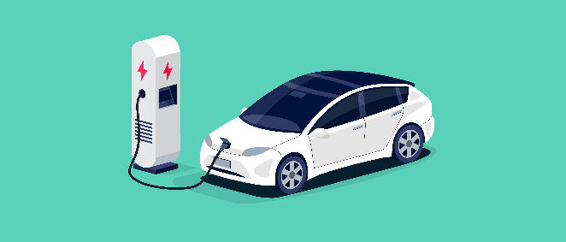

As a relatively young, scattered, and rapidly growing industry, EV charging terminology is all over the place. There are different charging levels[27], cables and plugs[28] (which differ depending on where you are), battery capacity possibilities, and estimated actual range[29].

Charging stations can also vary depending on the type of current they use (AC or DC), their power output, and their charging speed[30]. It doesn’t help that many EV charging terms are similar and often used interchangeably. For example, how fast is fast charging really? And what is rapid or even ultra-fast charging?[25]

**Where to charge an electric car?**

Generally speaking, any location you can park your car in with access to electricity is a potential charging location. So, you can imagine the places you can charge your EV are as diverse as today’s electric car models.

As the world is shifting towards electric mobility, the need for a suitable charging infrastructure network has never been more prevalent. As such, governments and cities across the globe are creating legislation and incentivizing the building of charging stations while more and more businesses are tapping into this new market.[26]

**Different types of chargers**

**EV charging levels and all types of chargers explained**

Charging can be categorized in multiple ways. The most common way to think about EV charging is in terms of charging levels. There are three levels of EV charging: Level 1, Level 2, and Level 3—and generally speaking, the higher the level, the higher the power output and the faster your new vehicle will charge. However, in practice, charging times are influenced by many things like the car's battery, charging capacity, the charging station's power output. But also the battery temperature, how full your battery is when you start charging, and whether you’re sharing a charging station with another car or not can also influence the charging speed.

The maximum charging capacity at a given level is determined either by your car’s charging capacity or the charging station’s power output, whichever is lower.[27]

**#Level 1 charger**

Level 1 charging simply refers to plugging your EV into a standard power socket. Depending on where you are in the world, a typical wall outlet only delivers a maximum of 2.3 kW, so charging via a Level 1 charger is the slowest way to charge an EV—giving only 6 to 8 kilometers of range per hour (4 to 5 miles). As there is no communication between the power outlet and the vehicle, this method is not only slow, but it can also be dangerous if handled improperly. As such, we don’t recommend relying on Level 1 charging to charge your vehicle except as a last resort.[27]

**#Level 2 charger**

A Level 2 charger is a dedicated charging station that you may find mounted to a wall, on a pole, or standing on the ground. Level 2 charging stations deliver alternating current (AC) and have a power output between 3.4 kW - 22 kW. They are commonly found at residential, public parking, businesses, and commercial locations and make up the majority of public EV chargers.

At the maximum output of 22 kW, an hour’s charging will provide roughly 120 km (75 miles) to your battery’s range. Even lower power outputs of 7.4 kW and 11 kW will charge your EV much faster than Level 1 charging, adding 40 km (25 miles) and 60 km (37 miles) of range per hour respectively.

Because of this reason, and thanks to a range of smart charging options, connectivity and safety features that Level 2 AC chargers offer, many EV drivers invest in an AC charging station for their home.[27]

**#Level 3 charging station (DC fast charger)**

Also known as DC or fast charging, Level 3 charging uses direct current (DC) to charge a vehicle’s battery directly, instead of the alternating current (AC) used by Level 1 and 2 charging stations. This allows Level 3 chargers to bypass an EV’s slower AC/DC onboard converter and deliver DC power directly to the battery.

As a result, Level 3 charging stations can deliver much more power faster, making them ideal for short-stop locations like gas stations and fleet depots. Charging times vary between different vehicles and power outputs, however, generally speaking, Level 3 chargers can charge a vehicle in minutes versus hours for Level 2 or days for Level 1 charging stations.[27]

**AC vs DC power**

So, the higher the level, the higher the charging speed. All clear so far, right? But what is AC and DC? When is something AC and when DC, and why is DC so much faster?[30]

**AC vs DC current**

AC stands for “Alternating Current”, and as its name implies, it changes direction periodically. DC stands for “Direct Current” and flows in a straight line. Without getting too technical, AC can be transported over long distances more efficiently, so this is why it flows out of your socket at your home and office. However, batteries are only able to store DC power, and electronics use DC to operate. You may have never realized it, but every time you charge your phone (or any other electrical device for that matter), the charger converts the AC power it receives from the grid into DC power to charge the battery in your device.[30]



**How do electric cars charge?**

The same principle goes for electric cars. The difference between AC and DC charging all depends on whether there is a conversion process or not. No matter how you charge it though, at the end of the day, the electricity stored in the car’s battery is always DC.

With a DC charger, power is converted from AC to DC by the charger, allowing direct current to flow straight into the battery. With an AC charger, the electricity has to be converted to DC by the car’s built-in converter before it can be fed into the battery. This process will always take longer as the onboard charger has a much more limited capacity than the external converters used in DC charging stations.[30]

**How long does it take to charge an electric car?**

**Level 1 (AC)**

**About 19 hours**

**Level 2 (AC)**

**Between 1h 45 min - 6h**

**Level 3 (DC)**

**Between 17 min - 52 min**

To give you a somewhat accurate approximation, we’ve added an overview of how long it takes to charge EVs below. This overview looks at three average battery sizes and a few different charging power outputs. For a more detailed overview of a specific model, have a look at our electric car specifications page.[33]

**Electric car charging times**

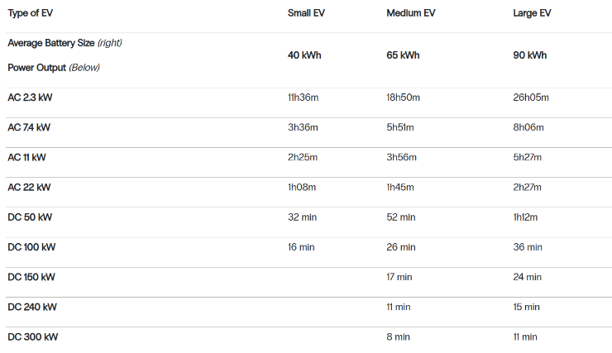

Approximate time to charge the battery from 20 percent to 80 percent state of charge (SoC).

For illustrative purposes only: Does not reflect exact charging times, some vehicles will not be able to handle certain power inputs and/or do not support fast charging.[31]

**What affects charging speeds?**

**Electric car battery**

The bigger the battery, the longer it will take to charge. Simple, right? An EV's battery capacity is measured in kilowatt-hours (kWh), similar to a liter or a gallon but for electricity, with each kWh equal to the amount of energy you would use to run a 1,000-watt appliance for an hour. The vast majority of electric passenger vehicle batteries today can hold somewhere between 25 and 100 kWh when fully charged, with the average EV having a 69 kWh battery capacity.[25]

**Charging capacity of the vehicle**

The maximum power an EV can accept differs from vehicle to vehicle and can even vary depending on the model of the car. Measured in kilowatts (kW), the charging capacity is shown for both AC charging and DC charging, and each is a large factor in determining how long it takes to charge. For instance, if two vehicles with similar-sized batteries are charging side by side at a high-power DC charging station, but one can only accept 50 kW of DC power and the other 250 kW, then the latter will charge much faster than the former.[25]

**The DC charging curve**

With AC charging, the power flow from the charger to an EV is mostly flat, meaning that it will charge at roughly the same speed from 0-100 percent full. In contrast, with DC charging, the EV’s battery initially accepts a very high flow of power, then quickly peaks and starts to decrease the power it takes in as it begins to fill up.

The reason for this pattern is twofold. You might remember from above that with AC charging, the conversion from AC to DC happens inside the vehicle by the onboard converter. This has a fairly limited power capacity, which is quickly reached and can be sustained throughout the whole charging session.

DC charging, on the other hand, unlocks much greater power output, so it needs to adjust this as the session progresses to avoid damaging the battery. Because of their chemistry, EV batteries can take in much higher power at low states of charge, and this ability decreases progressively as they get closer to full.

As a result, with a DC or Level 3 charger, the initial phase of charging (to 80 percent full) is much faster than the last 20 percent (which may take roughly the same amount of time as the first 80 percent).[30]

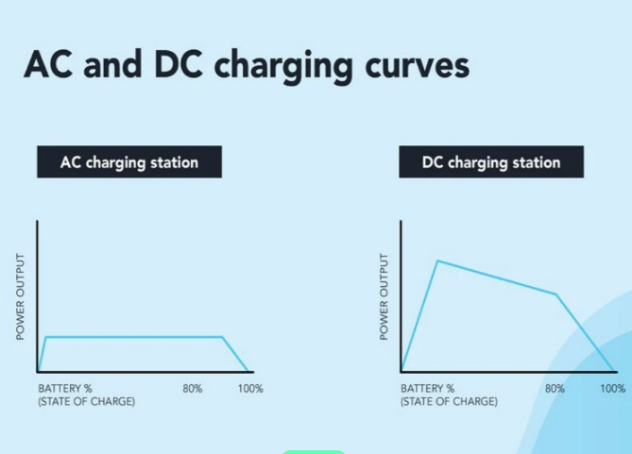

**EV cables**

Charging cables come in four modes. While each is most commonly used with a specific type of charging, these modes do not necessarily always correlate to the “level” of charging.[33]

**EV charging plug types (AC)**

The charging plug is a connector that you insert into the charging socket of an electric car. These plugs can differ based on power output, the make of the vehicle, and the country the car was manufactured in.

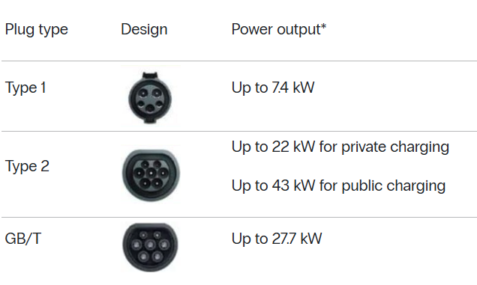

**AC charging plugs[31]**

**EV charging plug types (DC)**

**DC c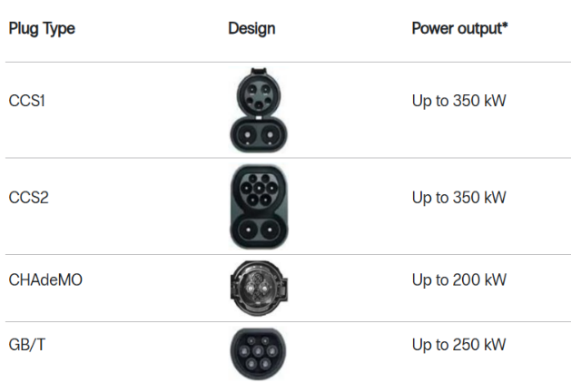harging plugs[31]**

**Cost to charge electric car**

Just like with how long it takes to charge an EV, the cost of charging depends on multiple variables including where you charge it, or the type of vehicle you drive.

Before we get into it in greater detail, here are the approximate costs of charging four different size vehicles (with battery packs from small to large), at three different

types of charging stations, so that you can get a ballpark idea of charging costs for your new EV.[31]

**Average cost to charge electric car**

**19**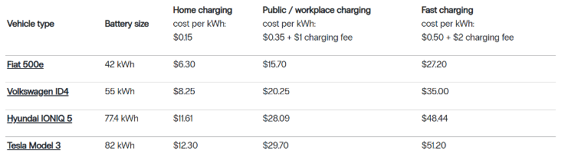

**Important: Prices for each charging segment are approximations based on our experience and do not represent a real-life situation. These calculations are based on a median guesstimate charging tariff and represent the cost to charge from zero to 100 percent.[33]**

**Types Of Battery**

**1.Lead Acid Batteries (VRLA, VLA, Pure Lead)**

Lead acid batteries have been in the UPS industry for decades in many different designs and forms, including:

-Valve Regulated Lead Acid (VRLA): Absorbent Glass Mat (AGM) and Gel Cell

-Vented Lead Acid (VLA): "Flooded" Batteries

-Pure Lead

Pure Lead Batteries and advanced VRLA AGM battery designs are great options for UPS applications that require increased power/energy density.

These battery designs have a larger footprint compared to most lithium-ion battery chemistries, but there are many different proprietary designs that allow for operating the batteries up to 35°C or higher with derated design life spans.[34]

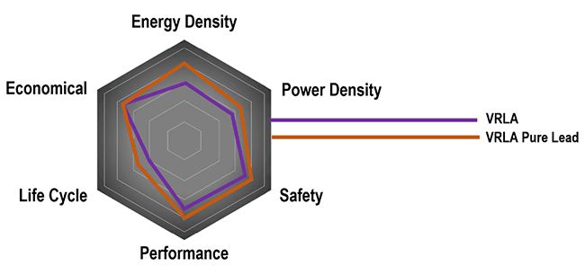

VLA is still used in UPS designs, though its utilization has dwindled in recent years due to its large footprint, quarterly required maintenance, and high cost compared to other lead acid battery types.[34]

**2.Lithium-ion Batteries**

Lithium-ion batteries were quickly adopted by the critical power industry starting around 2018. Since then, many chemistries have been introduced. The five main chemistries of lithium-ion in the UPS industry currently include:

-Lithium Manganese Oxide (LMO)

-Lithium Iron Phosphate (LFP)

-Lithium Nickel Manganese Cobalt Oxide (NMC)

-Lithium Titanate (LTO)

-Lithium Nickel Cobalt Aluminum Oxide (NCA)

These different chemistries have various materials and proprietary designs that provide unique levels of performance, power density, energy density, safety, cycle life, and design life.

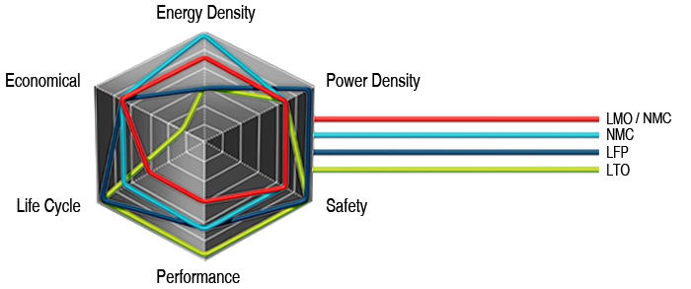

In its various forms, lithium-ion achieves higher power/energy density, specific energy, and energy efficiency when comparing a lead acid battery vs lithium-ion.[34]

**Lead Acid vs Lithium-ion for UPS Applications**

When evaluating a lead acid battery vs lithium-ion for UPS applications, it’s important to consider all the relevant factors and compare them to your needs. Below are comparisons between Lead Acid and Lithium-ion variations that examine energy density, maintenance, design life, cycle life & expanded application, total cost of ownership (TCO), weight, footprint, and safety[34]

1. **Energy Density**

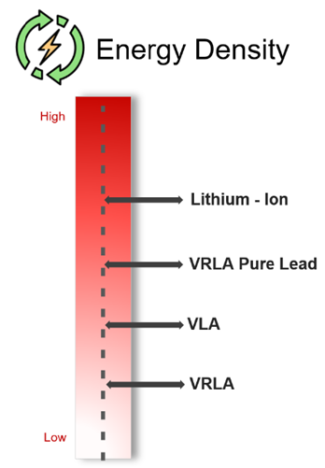

When comparing a lead acid battery vs a lithium-ion battery, lithium-ion has greater energy density. With power loads in the UPS industry increasing drastically, energy-dense battery solutions are imperative.

When comparing a VRLA battery vs lithium-ion battery specifically, lithium-ion has 3-to-5 times the energy density of VRLA, delivering the equivalent amount of energy in a significantly smaller footprint, and therefore, creating more flexibility in facility installation.[34]

1. **Maintenance**

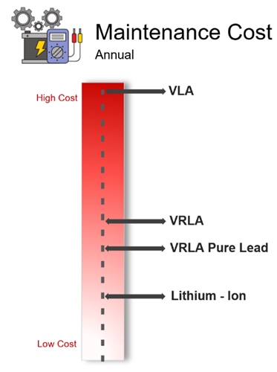

For lithium-ion, the yearly maintenance typically encompasses a visual inspection of the battery racks for warranty or performance guarantee requirements.

When comparing the recommended maintenance frequency of a VRLA battery vs. lithium-ion battery, lithium-ion is once a year, while VRLA’s maintenance visit frequency is twice a year, and VLA is four times a year (quarterly).[35]

1. **Design Life & Battery Replacement**

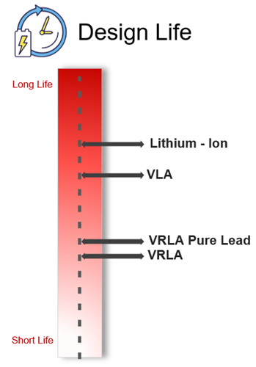

Design life is shorter and battery replacements are more frequent for lead acid vs. lithium-ion batteries. Most lead acid batteries must be replaced at least once during the life of a UPS and require more frequent maintenance visits.

Lithium-ion for UPS systems can last 15-20 years before reaching end-of-life (70-60% capacity), so no battery replacements are expected over the typical lifetime of the UPS.[34]

**Compare Battery Life Cycles:**

* **Lithium-Ion: 15-20 years**
* **Wet Cell VLA & 20-year VRLA: Up to 15 years**
* **Pure Lead: Up to 7 years**
* **VRLA: Every 3-5 years**

1. **Cycle Life & Expanded Application**

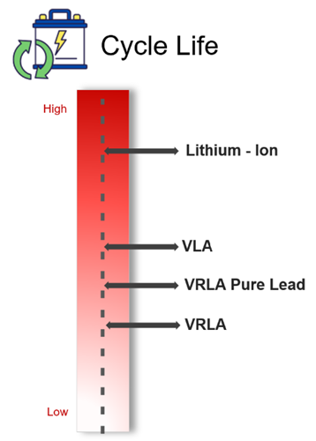

When comparing the cycle life of a VRLA battery vs a lithium-ion battery, lithium-ion generally comes out ahead. The increase in cycle life can support a battery system's implementation in an expanded application portfolio, such as Grid Interactive UPS use cases.

This also enhances the overall design life of most lithium-ion battery systems in traditional 5-15-minute UPS mission critical applications.

Lithium-ion can be cycled 25x more than VRLA, enabling longer lifespan, frequency response, and grid stabilization capabilities. Lithium-ion batteries also enable future possible grid interactive use cases, such as peak shaving.

Peak shaving saves utility costs by supporting load at peak demand. Batteries are discharged during peak demand and recharged during lower cost periods.[34]

1. **Total Cost of Ownership (TCO)**

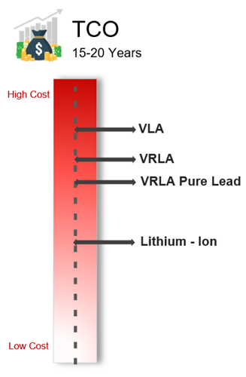

A longer design life and reduced frequency of replacement help decrease TCO. As batteries age, they need to be replaced. With VRLA batteries, the average life span is 3-5 years, depending on utilization.

VRLA Pure Lead batteries last slightly longer, with some manufacturers stating 6-10-year design lives. Even though VLA has an expected design life of 15 years, its quarterly maintenance demands can drive up costs over the life of the system.

TCO is also dependent on CAPEX, OPEX, recycling payback, and footprint costs. Overall, lithium-ion has a lower TCO due to its longer design life of 15-20 years, lower frequency of replacement, lower OPEX needs, and smaller footprint.

For lithium-ion batteries, over 65% of the total cost of ownership of the UPS system is reduced by lower maintenance, no battery replacement, and lower operating costs.[34]

1. **Weight**

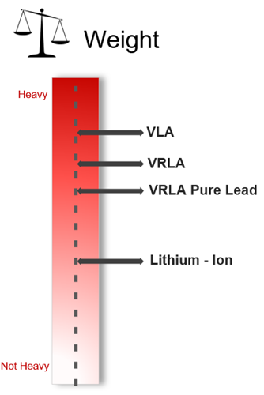

VLA is extremely heavy compared to lithium-ion batteries and can take up a lot of floorspace. The design of the battery room and floor need to be able to support the heavy weight.

VRLA and VRLA Pure Lead batteries have a lighter weight than VLA batteries but are still heavy. Conversely, lithium-ion batteries have a much lighter weight, which can lead to less costly floor designs. The reduction in weight also makes shipment and service of the batteries easier.[34]

1. **Footprint**

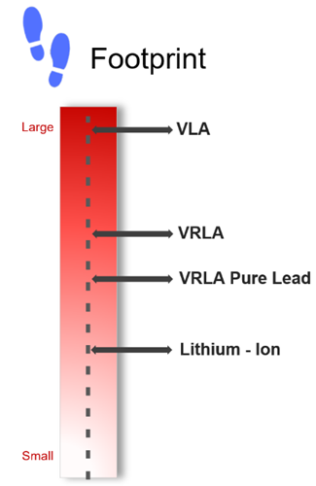

Lithium-ion batteries have a more favorable footprint compared to VRLA, VRLA Pure Lead, and VLA batteries. At 40-60% smaller than VRLA, lithium-ion batteries for UPS allow more floor space for revenue-generating equipment.

That advantage can lead to compact, dense floor spaces that can reduce the size and cost of a building - or allow for greater power to be installed within the same footprint. Lithium-ion batteries can support the growing need for a more power dense battery chemistry with a smaller footprint.[34]

1. **Safety**

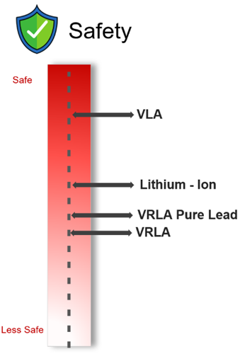

If improperly maintained and operated, all battery options including VLA, VRLA, Pure Lead, and lithium-ion have the potential to cause thermal runaway or other safety issues.

In addition to proper maintenance and operating conditions, it is critical to monitor and manage a battery chemistry’s operations to prevent safety risks.

Lithium-ion has a safety advantage per UL listing requirements since that technology requires a battery management system that is tailored to the specific battery chemistry and includes proprietary safety protection control measures.

VLA has a high safety rating due to the anode and cathode plates being fully submerged in an excess of liquid electrolyte, in addition to the maintenance and attention required to successfully operate a VLA battery system.[34]

*The variety of commercial applications, including electrical vehicles and battery energy storage systems, and the need to tailor specific lithium-ion chemistries to the required use case leads to a more complex safety profile than past battery types. The safety score here represents the use of lithium-ion batteries in a UPS application using top-tier battery cells and a lithium-ion chemistry that is properly used, controlled, and maintained.

**Lithium-Ion :-**

In traditional mission critical UPS applications for standby power of 5-15 minutes of runtime, a lithium-ion battery is generally on float most of the time. In this application, the battery discharges infrequently over the course of the year and limits the thermal stress in discharge and charge operations. Lithium-ion batteries have an integrated battery management system (BMS) that is specifically tailored to the chemistry and design of the battery system, offering proprietary specialized controls for charge rate, voltage, temperature, and protection settings.

This level of control and monitoring, paired with the traditional mission critical UPS application of 5-15 minutes of runtime, makes lithium-ion - in many ways - safer than VRLA and VRLA Pure Lead batteries. Lithium-ion cells that are obtained from a top-tier battery manufacturer undergo sufficient quality control procedures and meet the industry safety standards.[34]

**Lead Acid :-**

**Lead acid batteries are on float most** of the time as well, but they do not have a battery management system that controls charge, discharge, and temperature protections of the system. Lead acid systems rely on third-party battery monitoring software platforms that utilize generalized predictive data models and algorithms.

However, the lead acid battery monitoring and the thermal runaway protection device is not specifically designed for the battery and does not have the level of control and protection a lithium-ion battery management system can provide.[34]

**Size of the electric car battery**

The first thing you need to know when calculating how much it costs to charge your EV is the size of your battery. As shown above, the larger the battery, the more kWhs it can store; the more kWhs it can store, the more power it takes to fill the battery; the more power it takes, the more you have to pay to fill your battery. Simple, right?

For instance, a Tesla Model 3 Long Range with an 82 kWh battery costs about $12.30 to fully charge at home but has a range of roughly 614 km (381 miles). However, a Fiat 500e with a much smaller 42 kWh battery, while costing a fraction of the price to charge, only has a 321 km (200 miles) range.

Once you know how big your new EV’s battery is (measured in kWh), you can approximate how much it costs to charge at different charging stations. The three main options are at home, at public locations, or at fast-charging stations.[31]

**How long do electric car batteries last?**

Of the 15,000 vehicles, only 1.5% had been replaced. This excludes major battery recalls, such as the Chevy Bolt and Hyundai Kona. "So far, it seems that EV batteries have much longer lifespans than anyone imagined, since very few of them have been replaced," the study says.

The models with the highest rate of normal replacements were the Nissan Leaf (around 5%) and Tesla Model S (less than 5%). This is perhaps unsurprising, as they are some of the oldest on the market and in the fleet Recurrent tested.[36]

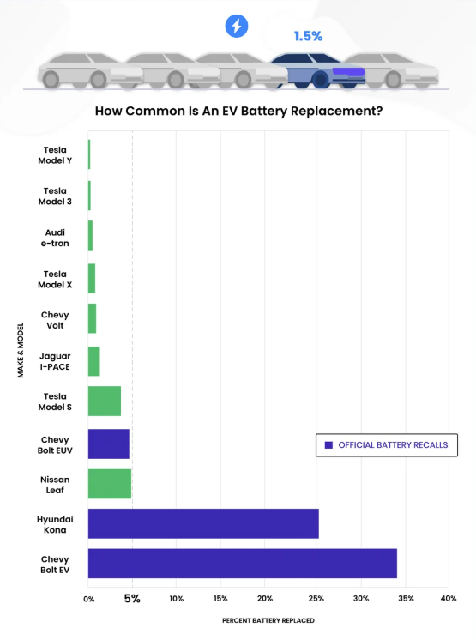

Electric vehicles typically come with a standard battery warranty, between eight and 12 years, plus a certain number of miles. Recurrent found that most drivers were not replacing their batteries even after those warranties expired.

The oldest models in the study have the highest percentage of battery replacements, at about 5% for those that have been on the road for nine to 12 years, according to the graph below. Twelve years is the current average lifespan for gas-powered cars in the US, according to Progressive.

This suggests a battery replacement could come at a natural time to consider buying a new vehicle or replacing the battery on the current one, not as an unfortunate surprise just a few years into ownership.[36]

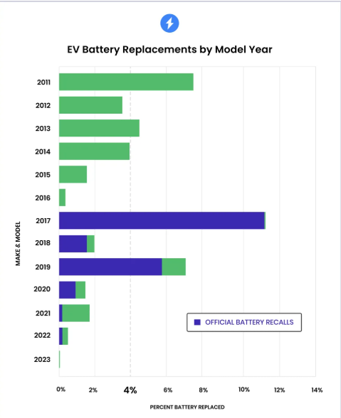

However, the study also found unusual spikes in non-recall-related battery replacements that suggest it could be related to the unique technology used in each model.[36]

**How long should a car battery last?**

According to current estimates, EV batteries have a projected lifespan of about 15 to 20 years or around 100,000 to 200,000 miles on the road. This is longer than the current average life expectancy of a car, which is approximately 12 years, so EV batteries will, in most cases, outlive the vehicle they’re in.

There are also a few simple habits you can adopt to maximize your EV’s battery life, such as only charging up to 80 percent for everyday driving and avoiding letting your car’s battery get close to empty.[29]

**EV charging cables and charger plugs**

**EV charging connector types explained**

Many of the sections above have answered questions you may or may not have had before purchasing your new EV. However, we can take a guess that you probably haven’t even thought about charging cables and plugs, the world of EV cables and plugs is as diverse as it is complex.

As different regions adopted EVs simultaneously, each developed its own cables and plugs, and there’s still no universal standard for charging to this day. As a result, just like Apple has one charging port and Samsung has another, many different EV manufacturers and countries use different charging technologies. To get a detailed overview of a specific model, our electric car specifications page shows the type of plug types and other specifications per car.[30]

Broadly speaking, the two main ways EV charging can differ are the cable connecting the car to the charging station or wall outlet and the type of plug used to connect the vehicle to the charging station.

The 85kWh battery has 7,616 18650 cells in parallel/serial configuration. At $250 per kWh, the cost is lower than other Li-ion designs.

EV manufacturers calculate the driving range under the best conditions and according to reports, the distances traveled in the real-world can be 30–37 percent less than advertised. This may be due to the extra electrical loads such as headlights, windshield wipers, as well as cabin heating and cooling. Aggressive driving in a hilly countryside lowers the driving range further.

Cold temperature also reduces the driving range. What battery users may also overlook is the difficulty of charging when cold. Most Li-ion cannot be charged below freezing. To protect EV batteries, some packs include a heating blanket to warm the battery during cold temperature charging. A BMS may also administer a lower charge current when the battery is cold. Fast charging when

cold promotes dendrite growth in Li-ion that can compromise battery safety(See BU-410: Charging at High and Low Temperature) [31]

**Compare Between Car Models ,Battery and Charge Time [32]**

**22**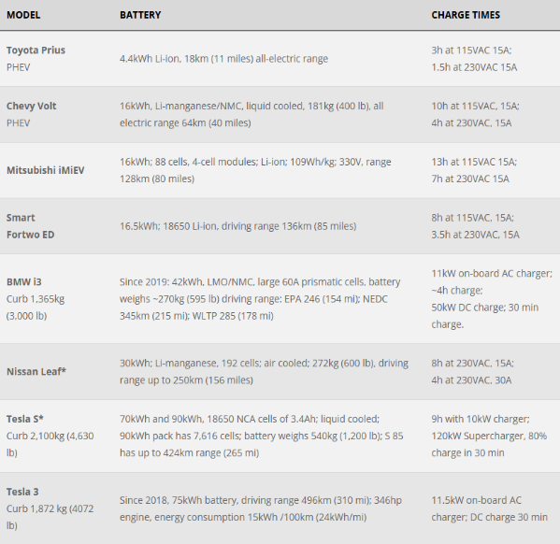

**Compare Between Car Models ,Range KM , WH/KM and Energy Cost/KM [32]**

**[32]**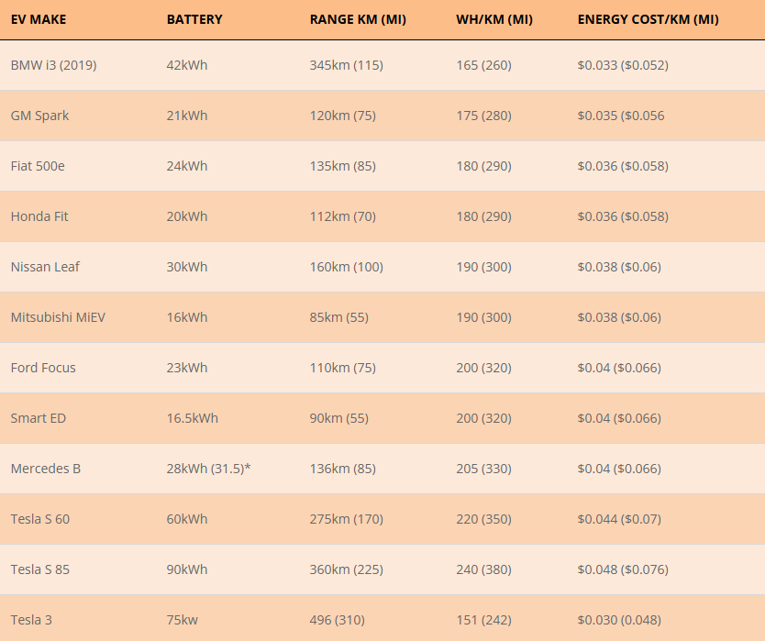

**[E] Dynamo**

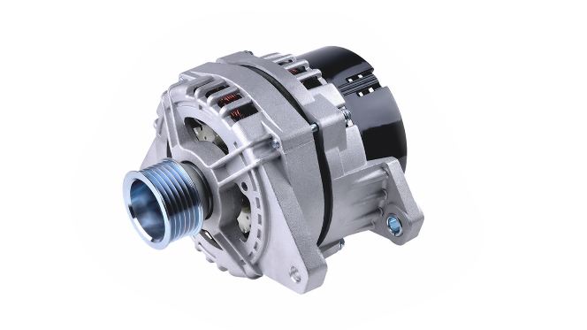

**How electric cars work is different from conventional cars. Likewise, an electric car dynamo is used to move its components. This tool has the role of converting electrical energy into mechanical energy so that electric cars can run optimally.**

**What is an Electric Car Dynamo?**

The electric car dynamo is a component in an electric car whose job is to convert electrical energy into motion energy. That way, the electrical energy available in the car will turn into mechanical energy. This is where the power is created to move the car.[42]

The car dynamo works on the principle of electromagnetic induction. According to this principle, current can be generated by rotating a coil or wire in a magnetic field or vice versa. The loop spinning creates a potential difference in the coil and keeps the current flowing.[42]

**Types of Electric Car Dynamo**

Generally, it is divided into two types: the third-brush dynamo and the two-brush dynamo. What is the difference?

The third-brush dynamo has three brushes connected to different vehicle parts. The first brush is connected to the vehicle body, the second to the battery terminals, and the third to the field winding (coil).[42]

The two-brush dynamo is the best electric car dynamo, which consists of two brushes, one connected to the battery and the other to the field winding (coil).

Of the two types, one of the dynamo brands for electric cars widely used worldwide is the Permanent Magnet Synchronous Motor (PMSM) type, which is considered very sophisticated compared to other types. PMSM is proven to have more efficient work and can produce ample torque consistently. In addition, PMSM is also less likely to experience power loss than induction-type dynamos. The reason is that the PMSM rotor is more excellent than the induction type.[42]

Even though it is very popular because of its advantages compared to other electric car dynamos, the use and production of PMSM are not that wide. The reason is that the price of this electric car driving dynamo requires quite a significant production cost. If you want to feel the use of PMSM, you can feel it on the Wuling Air ev electric car, which has been confirmed to use the PMSM dynamo.[43]

This car uses a Lithium Ferro-Phosphate IP67 battery that works together with the PMSM dynamo. The power generated is 30kW (40.2 dk) with a peak torque of 110 Nm. For 6,600 watt power, it takes 4 hours to charge the Air ev battery fully. But if you use 2,200 watts of power, it will take up to 11 hours to charge. As a mainstay "war car," the Air ev is very comfortable on the highway because it can move nimbly and makes it easy to park in confined spaces.[44]

This is the importance of PMSM, which can still be used to drive with Air ev. For example, when traveling long distances or to areas that are difficult to charge. Air ev owners don't need to worry because there are still dynamos that can run on fuel like most other cars.[42]

**Electric Car Dynamo Components**

The dynamo is one of the most crucial electric car components to replace the battery when needed. Well, the electric car dynamo itself has several components, including:

* Battery. Serves to store electricity that will be used as a driving force for the car and distributes electric current to the inverter. Electric car batteries are made of sturdy material, so they are not easily damaged even though they have been charged repeatedly.
* Controllers. Its function controls the electric power from the battery to the inverter. The new battery will send DC to the inverter after receiving a signal from the controller.
* Inverters. Receives DC electric current sent from the battery. The inverter is then in charge of converting the electric current into AC to drive the motor. Conversely, the inverter will also change from AC to DC when braking.
* Traction Motor. Drives the transmission and wheels of the car. Usually, there is more than one traction motor in an electric car.
* Auxiliary battery. This component is helpful as a storage area and a provider of electric current to turn on car accessories, such as air conditioners, alarms, car lights, and others.
* Thermal system. This is an electric car component that acts as a car engine coolant.
* DC converters. Because DC electricity in electric cars has a high voltage, a DC converter is needed to convert the electric current to a low voltage. The goal is that electric car components that only need low-voltage electricity can be energized.

**How the Electric Car Dynamo Works**

When using a battery, an electric car works by passing an electric current from a charged battery to other car components. This electric current drives the car, for example, moving the wheels and steering wheel. Here is a more detailed way of working:

* The gas pedal is pressed, and the signal is sent to the controller.
* The controller orders the battery to supply DC electric current to the inverter.
* DC electric current is converted to AC.
* AC is supplied to the traction motor with pressure according to the driver's pressure on the gas pedal.
* The electric current is converted to kinetic energy, which rotates to drive the wheels.
* The rotor will vibrate to drive the transmission system, and the car can move on.

**Meanwhile, how the electric car dynamo works are:**

* When the battery is not charged or about to run out, the machine will replace its function and start to heat up.
* The dynamo supplies power to the generator engine and converts energy from engine fuel into electrical energy to run and can simultaneously charge the battery.
* When the speed is low, the battery takes the electric power. Meanwhile, for additional power, when the car accelerates, the power is taken from the dynamo. There are also those who don't use the dynamo at all when driving at low speed.
* At a speed of 60-80 km/hour, the dynamo will completely take over the car. This is also the case when you have to overtake another vehicle. Basically, when you need high acceleration, the dynamo will take over.
* In hybrid cars, usually, when the car stops temporarily, the dynamo will stop. For example, energy will be taken from the battery when stopped at a red light. Starting from driving AC and other electronic components.

**That's how the electric car dynamo and some of its components work. The dynamo is what makes electric cars run even though they don't use fossil fuels.**

**[F] EnerGO**

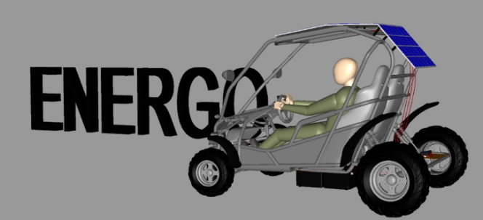

**The Energo team relies on the most important requirements of the human side,**

**after responding primarily to the natural side by providing the basic needs of drivers or car owners, by providing a car that is:**

* **Low maintenance cost**
* **Easy to navigate in congested large cities (Small Size)**
* **Keeping up with the wave of technology (Application)**
* **Safety**
* **Autonomous**
* **Low overall cost**

**Below, we show you how the car works :-**

Energo relies on two main sources of income: solar cells located on the top of the car and a dynamo. This depends on the range and duration of the car's movement. Both are connected to two batteries in the car to charge them. Both batteries are connected to the motor. The motor is connected to a button to move forward, and it has another button to make the car move in reverse, also connected to the motor. There is also a steering wheel to control the direction of the car's movement. There is also a phone application that provides the ability to know the car's location via GPS and to know the battery charge level and efficiency.

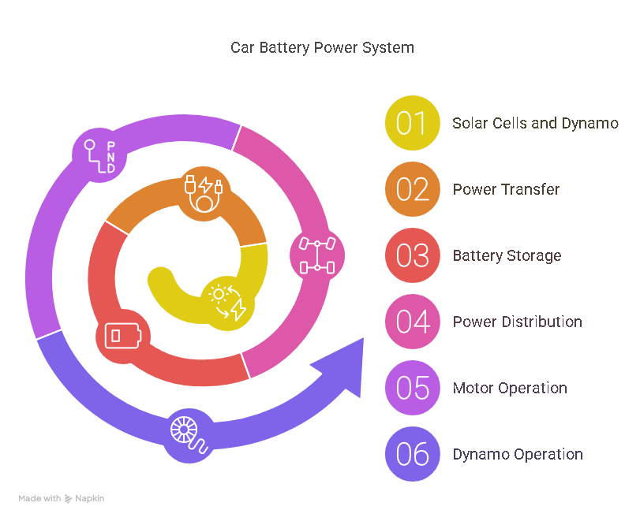

**Energy sources**

1. **Solar Panels**

**At Energo, we used Polycrystalline solar cells with a capacity of (18V – 50W) per panel. Three panels were used. The following is a general idea about the cells used:**

* **Polycrystalline Silicon**

Poly-crystalline solar cells are composed from many different silicon crystals, and are the most common type of solar cells produced. Large vats of molten silicon are carefully cooled, forming a block of silicon crystals which can be cut into thin slices for use in the solar panels. Solar panels made this way will appear to have a shiny metallic flake pattern, as the silicon crystals are facing different directions. Other elements such as boron or phosphorus are mixed with the molten silicon to give it different properties. Poly-crystalline cells are cheaper to manufacture than monocrystalline cells (made from a single large crystal) however are less efficient as the flow of electrons is disrupted by the change of direction between each new silicon crystal.[53]

* **How does the solar cell work?**

Solar cells transform light energy into electrical energy. Each cell is made up from two layers of silicon. The top layer is doped with an element with easily freed electrons (‘n-type’) such as phosphorus and the bottom layer is doped with an element which has free places for electrons (‘p-type’) such as boron. Where the two layers meet is a ‘depletion zone’ where the free electrons on one side have filled the available places in the other – no more electrons can pass from the n-type to the p-type through this barrier. When light hits the top electron-rich layer the photons free electrons, however they cannot pass through the junction to reach the spaces available for them on the other side so instead they travel through a wire which connects the two sides. This creates a flow of electrons in the wire – electricity! This phenomenon is called the photovoltaic effect and the electricity which is produced can be used directly or stored in a battery.[53]

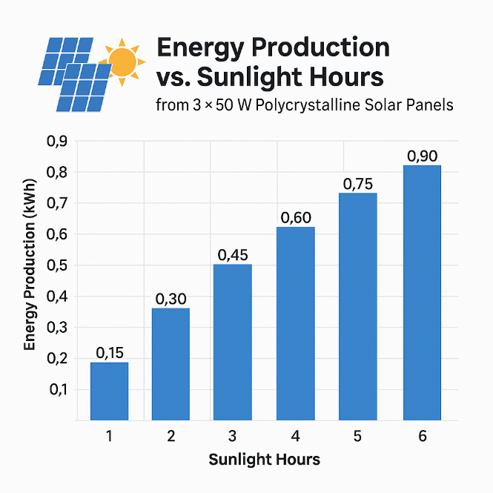

1. **Dynamo**

**We Used Dynamo 12 volt 60 Ampere**

**The idea of ​​installing a dynamo in the Energo It converts mechanical energy into electricity. We use it as a second source to charge batteries, and it can be used to generate electricity when there is no sun.**

* **Types of Dynamo**

Generally, it is divided into two types: the third-brush dynamo and the two-brush dynamo. What is the difference?

* The third-brush dynamo has three brushes connected to different vehicle parts. The first brush is connected to the vehicle body, the second to the battery terminals, and the third to the field winding (coil).
* The two-brush dynamo is the best Energo car dynamo, which consists of two brushes, one connected to the battery and the other to the field winding (coil).[54]
* **Electric Car Dynamo Components**
* Battery. Serves to store electricity that will be used as a driving force for the car and distributes electric current to the inverter. [Electric car batteries](https://wuling.id/en/blog/autotips/6-types-of-electric-car-batteries-how-to-care-for-them) are made of sturdy material, so they are not easily damaged even though they have been charged repeatedly.
* Controllers. Its function controls the electric power from the battery to the inverter. The new battery will send DC to the inverter after receiving a signal from the controller.
* Inverters. Receives DC electric current sent from the battery. The inverter is then in charge of converting the electric current into AC to drive the motor. Conversely, the inverter will also change from AC to DC when braking.
* Traction Motor. Drives the transmission and wheels of the car. Usually, there is more than one traction motor in an electric car.
* Auxiliary battery. This component is helpful as a storage area and a provider of electric current to turn on car accessories, such as air conditioners, alarms, car lights, and others.
* Thermal system. This is an electric car component that acts as a car engine coolant.
* DC converters. Because DC electricity in electric cars has a high voltage, a DC converter is needed to convert the electric current to a low voltage. The goal is that electric car components that only need low-voltage electricity can be energized.[54]
* **How the Electric Car Dynamo Works**

When using a battery, an electric car works by passing an electric current from a charged battery to other car components. This electric current drives the car, for example, moving the wheels and steering wheel. Here is a more detailed way of working:

* The gas pedal is pressed, and the signal is sent to the controller.
* The controller orders the battery to supply DC electric current to the inverter.
* DC electric current is converted to AC.
* AC is supplied to the traction motor with pressure according to the driver's pressure on the gas pedal.
* The electric current is converted to kinetic energy, which rotates to drive the wheels.
* The rotor will vibrate to drive the transmission system, and the car can move on.

Meanwhile, how the electric car dynamo works are:

* When the battery is not charged or about to run out, the machine will replace its function and start to heat up.
* The dynamo supplies power to the generator engine and converts energy from engine fuel into electrical energy to run and can simultaneously charge the battery.
* When the speed is low, the battery takes the electric power. Meanwhile, for additional power, when the car accelerates, the power is taken from the dynamo. There are also those who don't use the dynamo at all when driving at low speed.
* At a speed of 60-80 km/hour, the dynamo will completely take over the car. This is also the case when you have to overtake another vehicle. Basically, when you need high acceleration, the dynamo will take over.
* In [hybrid cars](https://wuling.id/en/blog/autotips/how-does-a-hybrid-car-work-based-on-its-type), usually, when the car stops temporarily, the dynamo will stop. For example, energy will be taken from the battery when stopped at a red light. Starting from driving AC and other electronic components.[54]

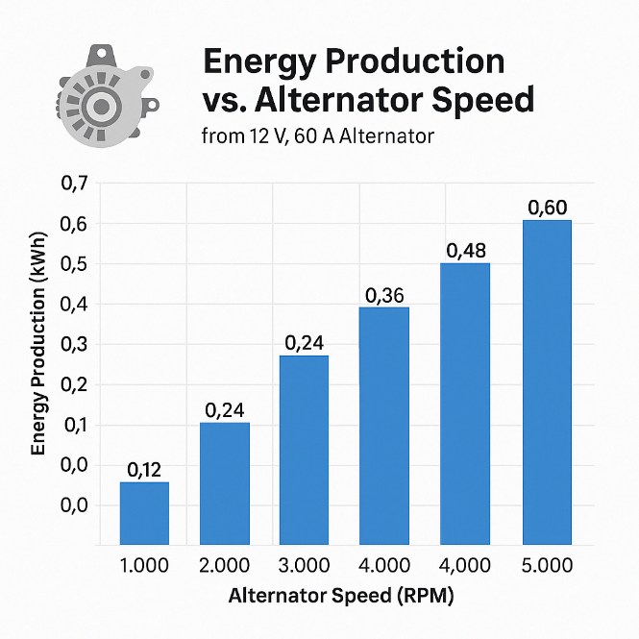

**Energy storage**

**Battery**

**(48V 20Ah lead acid battery) :-**

In the field of battery-powered vehicles and energy storage, the 48V 20Ah lead-acid battery is a popular choice due to its balance of capacity, performance, and cost. This section delves into the details of charging times, battery life, and efficiency, providing a comprehensive guide for users seeking optimal performance from their battery systems. Four lead-acid batteries were used for several reasons:

1. More energy storage

2. Faster charging and discharging

3. Improved performance and stability

4. Emergency backup.

* **How Long Does It Take to Charge a 48V 20Ah Lead Acid Battery?**

The charging time for a 48V 20Ah lead acid battery varies based on several factors including the charger’s output current and the battery’s state of charge. On average, charging a 48V 20Ah lead acid battery from a fully depleted state typically requires around 8 to 12 hours using a standard charger with a current rating of 10A. This duration can be reduced with a higher-output charger, but it is essential to use a charger that is compatible with lead acid batteries to avoid potential damage.[37]

* **Charging Efficiency and Considerations**

Lead acid batteries are known for their relatively slow charging rates compared to newer technologies like lithium-ion batteries. The charging process for lead acid batteries involves a multi-stage process, including bulk charge, absorption, and float stages. During the bulk phase, the charger provides a constant current until the battery reaches approximately 80% of its full charge. The absorption phase then allows the voltage to increase to complete the charging, and finally, the float stage maintains the battery at full charge. Proper maintenance of the battery, such as ensuring the electrolyte levels are adequate and keeping the terminals clean, can also impact the efficiency and duration of the charging process.[37]

* **Battery Life and Usage**

The 48V 20Ah lead acid battery is typically used in various applications such as electric bikes, golf carts, and backup power systems. The lifetime of this type of battery depends on usage patterns and maintenance practices. Under normal operating conditions, a lead acid battery of this type can last approximately 500 to 800 charge cycles. This lifespan translates to roughly 2 to 4 years if the battery is charged and discharged regularly.

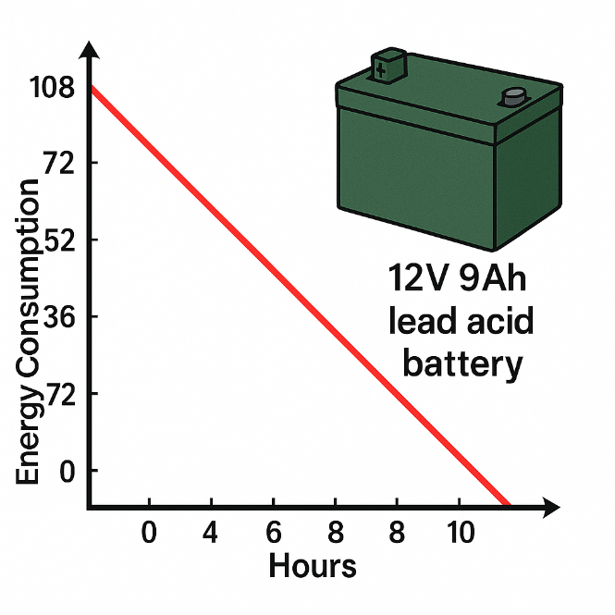

**Proper Maintenance Tips:**

1. Avoid Deep Discharges: Frequent deep discharges can significantly reduce the battery’s lifespan. Aim to keep the battery’s charge above 20%.
2. Regular Charging: Avoid leaving the battery in a discharged state for extended periods.
3. Temperature Control: Store and operate the battery in a cool, dry environment to minimize degradation. [38]

* **Performance Metrics: How Far Will a 48V 20Ah Battery Last?**

When it comes to performance, the range of a 48V 20Ah battery depends on various factors including the weight of the load, terrain, and the efficiency of the motor. In theory:

With Two Riders and a Load of 150 kg: A well-maintained 48V 20Ah battery pack could offer a range of approximately 40 kilometers.

With One Rider and Minimal Load: The same battery pack could extend the range to about 70 kilometers.

The efficiency of the accelerator pedal and the driving conditions also play crucial roles. For instance, a smaller accelerator or a more conservative driving style can lead to extended mileage.[37]

* **Advantages of 48V Battery Systems**

Choosing a 48V battery system provides several advantages over lower voltage alternatives:

1. Space Efficiency: 48V batteries offer higher energy density, meaning they can store more energy in a smaller physical space.
2. Reduced Current Draw: Higher voltage systems draw less current for the same power output, which reduces the risk of overheating and improves safety.[37]

* **Understanding Watt-Hours in 48V 20Ah Batteries**

To gauge the energy capacity of a 48V 20Ah battery, it’s useful to calculate its watt-hours (Wh). This is achieved by multiplying the voltage by the amp-hour rating:

48V x 20Ah = 960Wh

This metric indicates the total energy the battery can store and is crucial for determining the range and efficiency of battery-powered systems.[39]

While the 48V 20Ah lead acid battery offers a cost-effective solution, newer technologies like lithium-ion batteries provide enhanced performance and longer lifespan, making them a worthy consideration for those seeking optimal efficiency and durability.

**Move the car**

**Motor**

**(48V750W 2.39Nm,3000rpm) :-**

The motor is the main component responsible for the movement in Energo. And we used 750W BLDC motor. 3-phase brushless DC motor featuring no-load speed 3300 rpm, 2.39 Nm rated torque and 19.52A rated current. 48V high torque brushless DC motor runs smoothly, with little interference, long life and low maintenance cost.

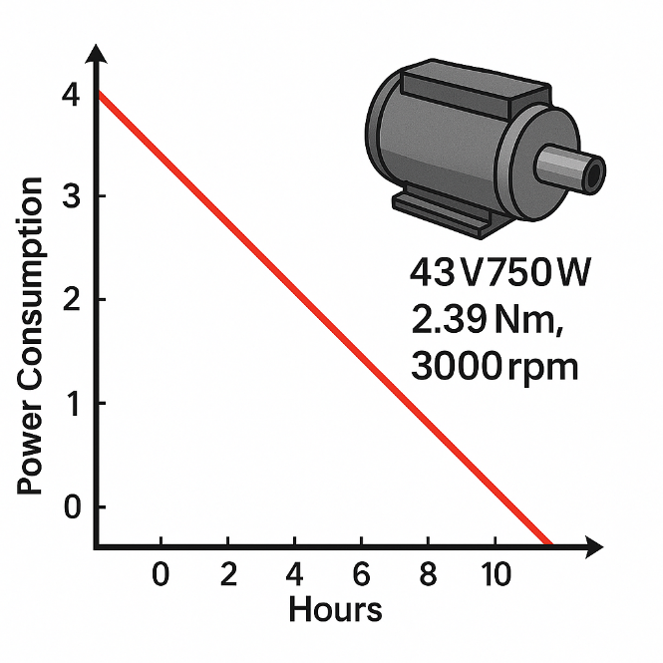

**Features**

**Stable speed control:** 48V brushless motor continues to set speed and a feedback signal is compared from the speed of the motor to adjust the voltage applied to the motor; therefore, even if the load change, still can set the speed from slow instantaneous adjustment to, and in order to stabilize the running speed.

**Thin, high power:** 3 phase DC motor adopts a permanent magnet brushless motor rotor, thus realizing the thin and high power.

**Wide speed control range:** 750W brushless DC motor speed control range than speed ac motor and inverter wider, because unlike the speed ac motor that at low speed have restrictions on the use of torque, so there is no brush motor is suitable for from low speed to high speed, all require the use of a certain torque.

**Contribute to energy saving:** The rotor of the brushless dc electric motor is used for the permanent magnet, which can reduce the two-loss of the rotor, so the power consumption is reduced by more than 20% compared with the three-phase induction motor with variable frequency control, which is helpful for the energy saving of the device.

**Equipped with protection function:** 48V 750W BLDC motor can help to protect the safety of the equipment system.[40]

**Dimension (Unit: mm)**

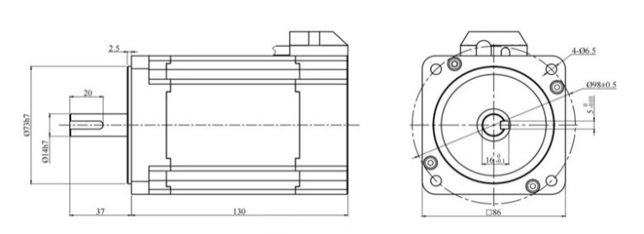

**Speed - Torque Curve**

**‘**

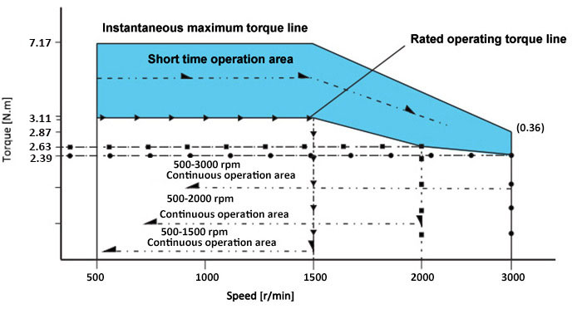

* Instantaneous maximum torque line

The maximum torque momentarily impacts the load when the motor is started.

Beyond this torque, the over-current protection of the driver will cause the motor to stop.

* Short-time operation area

The motor can run for a short time within this torque range at different speeds.

If the operation time is too long, the motor will generate heat, which may cause the motor to stop or burn.

* Rated operating torque line

The rated torque of the motor runs at different speeds, and the motor can run for a long time at this torque.

* Continuous operating area

When the motor rotates at different speeds, it runs continuously in this corresponding zone.[40]

**CONTROLLER**

**(48V 750W BLDC MOTOR CONTROLLER)**

**What is a Motor Controller?**

An electronic motor controller is an accessory that controls the running of an electric motor in terms of speed, amplitude, and direction. It also works as a regulator through which the motor is connected to the power source, and the motor's performance is checked to guarantee flexibility. These devices have found their applications in many applications to improve the motors' performance, decrease energy consumption, and finally guard the motors against possible deterioration.

Some extra functions involved in motor control include over-current protection, which must guarantee that the motor offers optimal safe operation. In doing so, they guard against the motor overheating, developing short-circuiting and mechanical failures, and overall increase the motor's durability.[49]

**How Motor Controllers Work?**

Before moving on to a motor controller's complex structure and functioning, it is essential to classify the essential needs and tools. A typical motor controller includes the following:

**Power Input:** The direction of the motor can either be AC or DC and is controlled through power supplied by a controller.

**Control Circuit:** This is the very core of the motor controller, where signals from the user or the system are received and converted into appropriate signals to respond to the contained motor.

**Switching Elements:** These components include transistors or relays, which will either allow or break the flow of electricity supplied to the motor.

**Feedback System:** Most high-precision motor controllers used in industrial applications have feedback systems, often in the form of a sensor or an encoder that gives real-time information on the status of the motor for real-time corrections to be made where necessary.[49]

**Types of Motor Controller**

There are numerous motor controllers, basically controlled by the type of motor and the needed control. Here are some of the most common types of motor controllers:

**AC Motor Controllers:** These controllers are for use with motors operating on the AC type of power supply. They are very efficient in power consumption and offer good speed control to large motors, so they are widely used in various industries. AC motor controllers normally come with variable frequency drives (VFDs) to control the motor's speed and torque.

**DC motor controllers:** These motors operate on direct currents, and the controller used on these motors is the DC motor controller. DC motor controllers give speed control and are best suited for different uses where accurate speed is important, such as robots and conveyors.

**Servo Motor Controllers:** Servo controllers are employed in accurate position control in various uses, for instance, Computer Numeric Control machines or automated systems. They are characterised by high positioning accuracy and speed control, making these types of sensors suitable for highly professional manufacturing processes.

**Stepper Motor Controllers:** Stepper motor controllers are mainly found in positioning applications whereby the motor makes incremental movements. It is frequently used in 3D printers and medical equipment.

Essentially, these categories of motor controllers are developed in a manner that they can accommodate particular motor kinds and uses. General details about the motor controllers make it easier to choose the proper motor controller for a specific motor to ensure that it will be a proper one for the longest time.[49]

**We Use**

Low voltage cut down 42v Reverse and Forward Movement both are available in the controller High efficiency and low noise gives smooth motor performance .High power mosfets drives the bldc motor with PWM Techniques .Protection For Over heating .latest intelligent micro controller use for high efficiency and smooth motor performance & Controller is having 24 MOSFETS ( TUBES ) "[41]

**Arduino**

We Used Arduino uno r4 wifi

It has many important benefits that contribute to improved performance and efficiency.

To control electronic systems: motor, battery, and lighting.

Battery monitoring

GPS system

Speed control

Temperature monitoring

All of this is displayed on a screen inside the car and is also connected to the car's app.

**Chassis**

We focused on reducing weight as much as possible and reducing costs, but we will certainly work on other designs for future EnerGo releases

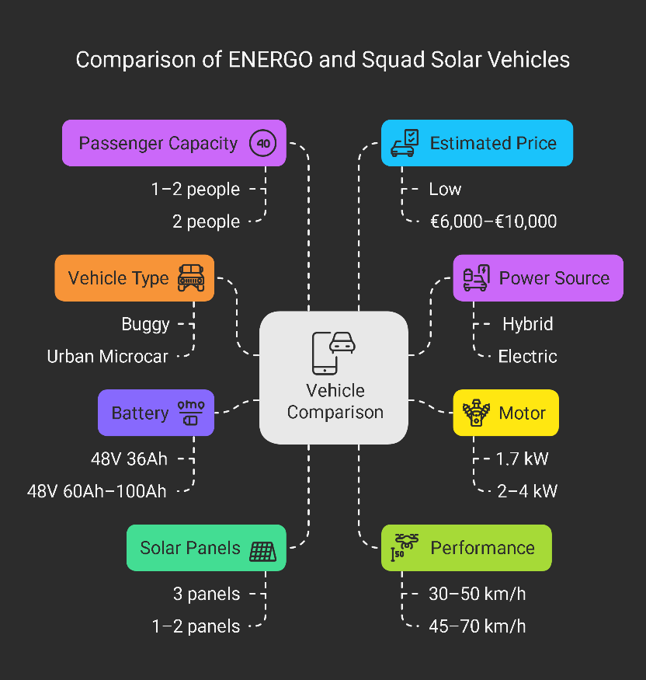

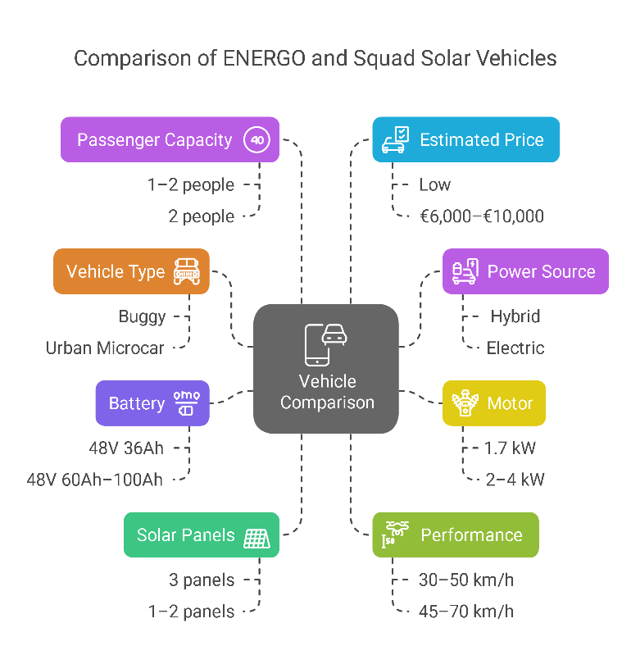

### **1. General Specifications**

| **Feature** | **ENERGO** | **Squad Solar (EU Model)** |
| --- | --- | --- |
| **Vehicle Type** | buggy | L7e-certified urban microcar |
| **Power Source** | Hybrid (Solar panels + Dynamo ) | Electric (Battery + Solar assistance) |
| **Motor** | 750W | 2–4 kW (more powerful) |
| **Battery** | 48V 36Ah (1.7KWh) | 48V 60Ah–100Ah (2.8–4.8 kWh) |
| **Solar Panels** | 3 panels (150W total) | 1–2 panels (200–400W) |
| **Solar Charging Time** | 4–5 hours (full charge) | Partial charging (adds 10–30 km/day) |
| **Top Speed** | 30–50 km/h | 45–70 km/h (varies by model) |
| **Range (Battery Only)** | 15–23 km | 80–100 km (full charge) |
| **Passenger Capacity** | 1–2 people | 2 people |
| **Estimated Price** | Low (DIY build) | €6,000–€10,000 |

### **2. Strengths & Weaknesses**

#### **ENERGO:**

✅ **Pros:**

* Low cost (if self-assembled).
* Customizable (expandable batteries/panels).
* Hybrid system (solar + dynamo).

❌ **Cons:**

* Limited range (15–23 km).
* Low speed (<50 km/h).

#### **Squad Solar:**

✅ **Pros:**

* **EU-approved** (L7e certification).
* Better range (80–100 km) + solar boost.
* Weatherproof design (roof, doors).

❌ **Cons:**

* Higher price (€6K–€10K).
* Requires grid charging (solar is supplemental).

**Reference**

**[1] https://www.cam.ac.uk/research/news/electric-cars-better-for-climate-in-95-of-the-world**

**[2] https://www.nature.com/articles/s41893-020-0488-7**

**[3] https://afdc.energy.gov/vehicles/how-do-all-electric-cars-work**

**[4] https://afdc.energy.gov/fuels/electricity-stations**

**[5] https://afdc.energy.gov/vehicles/how-do-plug-in-hybrid-electric-cars-work**

**[6] https://afdc.energy.gov/vehicles/electric-basics-phev**

**[7] https://www.greencars.com/greencars-101/electric-car-charging-tips**

**[8] https://www.greencars.com/greencars-101/benefits-of-electric-cars**

**[9] https://www.greencars.com/greencars-101/environmental-impact-of-ev-batteries**

**[10] https://www.greencars.com/greencars-101/charging-electric-cars-at-home**

**[11] https://www.greencars.com/greencars-101/overview-of-ev-incentives**

**[12] https://www.greencars.com/greencars-101/owning-an-electric-car**

**[13] https://www.dtu.dk/english/research/areas/energy-technology/solar-energy**

**[14] https://www.greenmatch.co.uk/blog/09/types-of-solar-panels**

**[15] https://www.greenmatch.co.uk/solar-energy/solar-panels/cheap**

**[16] https://www.greenmatch.co.uk/solar-energy/solar-panels/black**

**[17] https://www.greenmatch.co.uk/solar-energy/solar-panels/integrated\**

**[18] https://www.greenmatch.co.uk/solar-energy/solar-panels/bifacial**

**[19] https://en.m.wikipedia.org/wiki/Sono_Motors_Sion**

**[20] https://aptera.us/solar/**

**[21] https://aptera.us/vehicle/**

**[22] https://www.pv-magazine.com/2023/02/27/sono-motors-scraps-development-of-sion-solar-cars/**

**[23] https://www.newcastle.edu.au/research/priorities/defence-capability/capability-summaries/communications-electronics-and-digital-tech/printed-solar-panels**

**[24] https://www.ch.cam.ac.uk/news/better-arranged-molecules-improve-solar-panel-efficiency**

**[25] https://evbox.com/en/ev-charging-guide**

**[26] https://blog.evbox.com/charging-locations**

**[27] https://blog.evbox.com/ev-charging-levels**

**[28] https://blog.evbox.com/charging-cables-and-plugs**

**[29] https://blog.evbox.com/far-electric-car-range**

**[30] https://blog.evbox.com/ev-charging-times**

**[31] https://evbox.com/en/electric-cars**

**[32] https://batteryuniversity.com/article/bu-1003-electric-vehicle-ev**

**[33] https://blog.evbox.com/ev-charging-levels**

**[34] https://www.mitsubishicritical.com/uninterruptible-power-supplies/battery-and-dc-technologies/lithium-ion-vs-vrla/**

**[35] https://www.mitsubishicritical.com/services/ups-battery-maintenance/**

**[36] https://me.pcmag.com/en/cars-auto/20174/how-long-do-ev-batteries-last-new-research-suggests-its-way-longer-than-you-might-think**

**[37] https://www.redwaypower.com/understanding-the-charging-and-longevity-of-a-48v-20ah-lead-acid-battery/**

**[38] https://www.redwaypower.com/what-are-vrla-battery-temperature-considerations/**

**[39] https://www.redwaypower.com/understanding-the-48v-20ah-lithium-ion-battery-key-insights-and-detailed-analysis/**

**[40] https://www.brushless.com/48v-750w-1-hp-brushless-dc-motor**

**[41] https://www.flipkart.com/humser-48v-750w-bldc-motor-controller-electronic-components-hobby-kit/p/itmc419f9d1cedcb?**

**[42] https://wuling.id/en/blog/autotips/electric-car-dynamo-the-components-and-how-it-works**

**[43] https://wuling.id/en/air-ev**

**[44] https://wuling.id/en/blog/autotips/how-strong-is-the-battery-life-of-electric-cars**

**[45] https://www.nature.com/articles/nphoton.2012.11**

**[46] Rogers, J. A., Someya, T. & Huang, Y. Materials and mechanics for stretchable electronics. Science 327, 1603–1607**

**[47] Kim, D.-H. et al. Dissolvable films of silk fibroin for ultrathin conformal bio-integrated electronics. Nat. Mater. 9, 511–517 .**

**[48] Kaltenbrunner, M. et al. Ultrathin and lightweight organic solar cells with high flexibility. Nat. Commun. 3, 770**

**[49] https://eshop.se.com/in/blog/post/motor-controller-working-principle-types-explained.html**

**[50] https://www.un.org/en/climatechange/raising-ambition/renewable-energy**

**[51] https://pod-point.com/guides/driver/how-long-to-charge-an-electric-car**

**[52] https://infinityevcharge.com/**

**[53] https://physics.anu.edu.au/engage/outreach/_files/Solar%20Panel_Polycrystalline.pdf**

**[54]** [**https://wuling.id/en/blog/autotips/electric-car-dynamo-the-components-and-how-it-works**](https://wuling.id/en/blog/autotips/electric-car-dynamo-the-components-and-how-it-works)

